Registered Scottish Charitable incorporated Organisation number SCO54024
COMMUNITY ARTS PENICUIK
BURSARY FUND INFORMATION AND APPLICATION
Community Arts Penicuik are delighted to be offering a limited number of bursaries up to £500 for individuals, community groups and organisations based in Penicuik.
The Bursary will open on 12th June and close on 31st October 2026.
Applications will be scored and assessed by Trustees of Community Arts Penicuik.
Eligibility criteria
- You must be an individual, community group or organisation based in Penicuik
- The Bursary can be used for anything relating to the arts and can include but is not exclusive to:equipment, expenses for events, instruments, performances, workshop costs and materials.
- The closing date for the bursary is 31st October 2026.
- Applicants will be notified week beginning 16th November
- Any activity must start within the 2026 financial year, i.e. before 31st March 2027.
- If an applicant is under 16, the application must be made by a parent, guardian or teacher
- Any equipment or material purchases must have a quote included in the application.
- Applicants must have a UK based bank account.
- All applicants must provide a feedback form 28 days following the completion of the activity
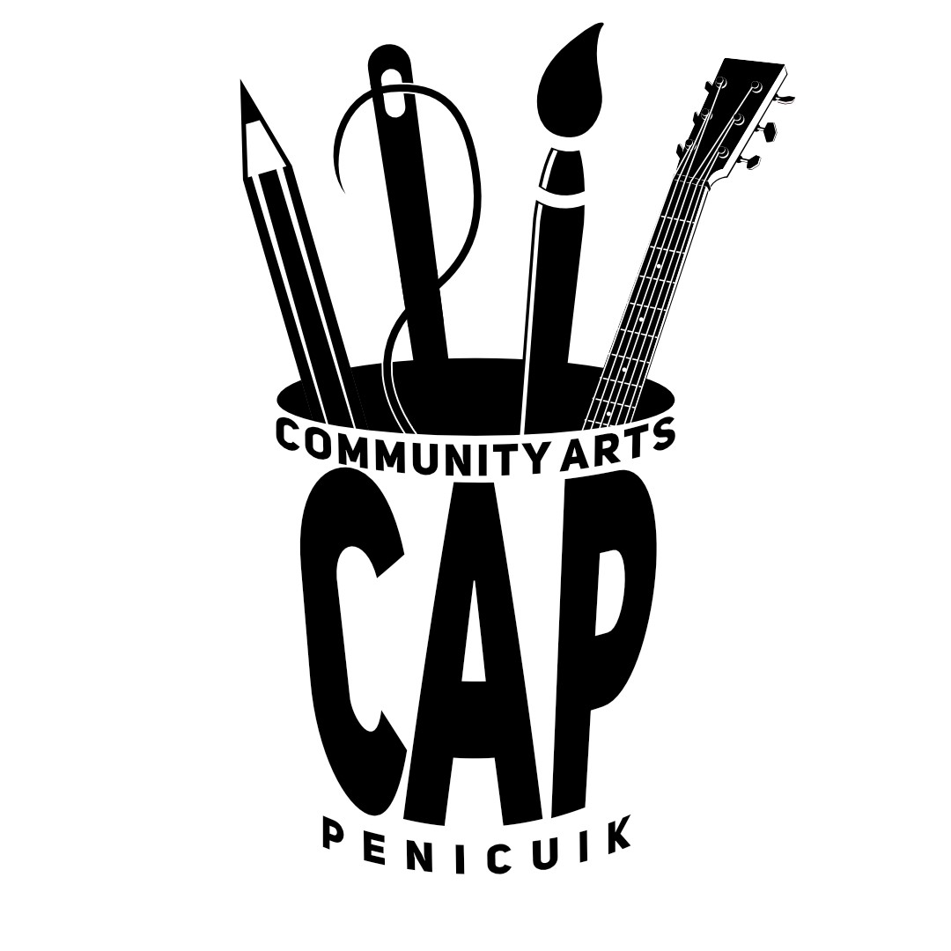
- Please email all applications and quotes to secretary.communityarts@gmail.com with your name and CAP bursary in the subject heading
- If you would like to submit the form in another way please contact the above address
Application
Name of Applicant or organisation……………………………………………………………..
Main contact name If an organisation or community group…………………………………
Postcode…………………………………………………………………………………………..
Contact email:…………………………………………………………………………………….
Contact Phone number:………………………………………………………………………….
Do you have a UK bank account?………………………………………………………………
Are you applying on behalf of someone else? If yes, please tell us who and what is your
relationship to them……………………………………………………………………………..
Question 1. Tell us about yourself or your group or organisation (200 words or less)

Question 2: How much money are you requesting ? (Up to £500)

Question 3: What will the money be used for? (200 words or less)

Question 4: What difference would this make to you? (200 words or less)

Question 5: If the funds are to be used for equipment or materials have you included a quote? YES/NO
If you have answered no to the above, please explain why you do not have a quote?

Question 6: will your activity or purchase take place or start before 31st March 2027

Question 7: what is the anticipated completion date of your activity?

