
Include this form with your artworks: One per artist
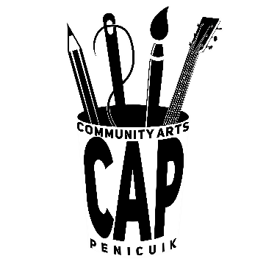
ENTRY FORM FOR PENICUIK TURNER PRIZE 2026 Contact information is for office use only. It will not be available to the public.
 | Name of artwork | Materials used | price
Artwork 1
Artwork 2
Artwork 3
CONTACT DETAILS
Name
email
tel
Postal address and post code

DETAILS OF ARTWORK Artists are allowed up to 3 entries

ON THE BACK OF THE ARTWORK PLEASE WRITE:
Your name, the name of the piece, materials and price

